ST. MARYS NURSERY SCHOOL - NAKIFUMA

END TERM II EXAMS 2023

LEARNING AREA 1: SOCIAL DEVELOPMENT

MIDDLE CLASS (4 - 5) YEARS

NAME …………………………………………………..................................................

**1. Read these sounds.**

flower

kettle

basket

bottle

bucket

elephant

orange

**2. Match words to pictures.**

 kettle

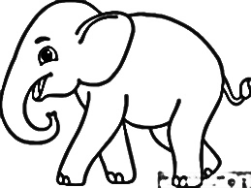bottle

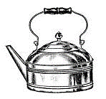

flower



elephant

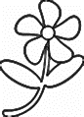

umbrella

**3. Fill in the missing letters.**

b \_\_\_ sk \_\_\_ t k \_\_\_ ttle fl \_\_\_ w \_\_\_ r

**4. Write the letters between.**

a \_\_\_\_ c

e \_\_\_\_ g

o \_\_\_\_ q

x \_\_\_\_ z

j \_\_\_\_ l

**5. Fill in the missing letters.**

r \_\_\_ d

gr \_\_\_ \_\_\_ n

bl \_\_\_ ck

y \_\_\_ ll \_\_\_ w

blu \_\_\_

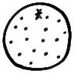6. Make sentences using **Here is an**

\_\_\_\_\_\_\_\_\_\_\_\_\_\_\_\_\_\_\_\_\_\_\_\_\_\_\_\_\_\_\_\_\_\_\_

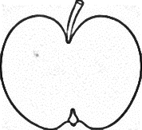

\_\_\_\_\_\_\_\_\_\_\_\_\_\_\_\_\_\_\_\_\_\_\_\_\_\_\_\_\_\_\_\_\_\_\_

\_\_\_\_\_\_\_\_\_\_\_\_\_\_\_\_\_\_\_\_\_\_\_\_\_\_\_\_\_\_\_\_\_\_\_

\_\_\_\_\_\_\_\_\_\_\_\_\_\_\_\_\_\_\_\_\_\_\_\_\_\_\_\_\_\_\_



\_\_\_\_\_\_\_\_\_\_\_\_\_\_\_\_\_\_\_\_\_\_\_\_\_\_\_\_\_\_\_\_\_\_\_

**7. Name these colours.**

**8. Name these pictures.**

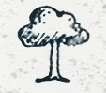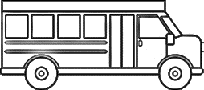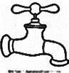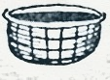

**9. Match actions to words.**

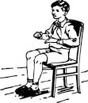

standing

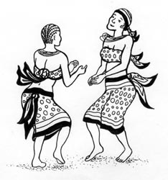

reading

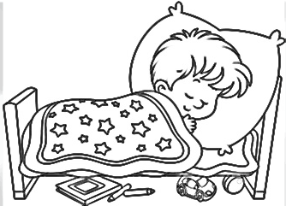

sitting

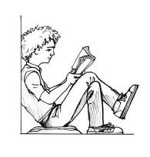

dancing

ttt

sleeping

ST. MARYS NURSERY SCHOOL - NAKIFUMA

END TERM II EXAMS 2023

LEARNING AREA: LANGUAGE DEVELOPMENT

MIDDLE CLASS (4 - 5) YEARS

NAME …………………………………………………..................................................

**1. Read these sentences.**

It is a leaf

I like meat

I like eggs

Mother is cooking food

Here is a flower.

**2. Fill in the missing syllables.**

ba \_\_\_\_\_ \_\_\_\_\_ bo bu

ma me \_\_\_\_\_ mo mu

ta te ti \_\_\_\_\_ \_\_\_\_\_

**3. Cross only syllables.**

bench pin bucket bottle basket

1. **form words from the vowels**

a \_\_\_\_\_\_\_\_\_\_\_\_\_\_\_\_\_\_\_\_\_\_\_\_\_

e \_\_\_\_\_\_\_\_\_\_\_\_\_\_\_\_\_\_\_\_\_\_\_\_\_

i \_\_\_\_\_\_\_\_\_\_\_\_\_\_\_\_\_\_\_\_\_\_\_\_\_

o \_\_\_\_\_\_\_\_\_\_\_\_\_\_\_\_\_\_\_\_\_\_\_\_\_

u \_\_\_\_\_\_\_\_\_\_\_\_\_\_\_\_\_\_\_\_\_\_\_\_\_

1. Read words of sound **oo**

food

stool

moon

spoon

school

**6. Write a syllable for the picture**

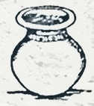

7. Join syllables to sounds and form words.

ba - g = \_\_\_\_\_\_\_\_\_\_\_\_\_\_\_\_\_\_\_

te - n = \_\_\_\_\_\_\_\_\_\_\_\_\_\_\_\_\_\_\_

pi - n = \_\_\_\_\_\_\_\_\_\_\_\_\_\_\_\_\_\_\_

bo - x = \_\_\_\_\_\_\_\_\_\_\_\_\_\_\_\_\_\_\_

**8. Underline words of sound ea.**

It is a leaf

I like meat

eat food

Here is a bean

A boy has a jean

**9. Form words from syllables.**

ba \_\_\_\_\_\_\_\_\_\_\_\_\_\_\_\_\_\_\_

ca \_\_\_\_\_\_\_\_\_\_\_\_\_\_\_\_\_\_\_

ma \_\_\_\_\_\_\_\_\_\_\_\_\_\_\_\_\_\_\_

ti \_\_\_\_\_\_\_\_\_\_\_\_\_\_\_\_\_\_\_

do \_\_\_\_\_\_\_\_\_\_\_\_\_\_\_\_\_\_\_

**10. Tell these syllables.**

ba fa ma ca va

ST. MARYS NURSERY SCHOOL - NAKIFUMA

END TERM II EXAMS 2023

LEARNING AREA: SOCIAL DEVELOPMENT

MIDDLE CLASS (4 - 5) YEARS

NAME …………………………………………………..................................................

1. **Oral questions**

What is the name of your class teacher?

What is the name of your director?

What is the colour of your uniform?

What is your school motto?

How many fingers do you have?

**2. Name people found at home.**



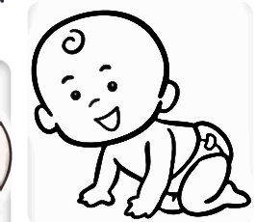

**3. Read and draw things for cleaning the environment.**

basket rake hoe

broom panga slasher

**4. Write a sound for the given animal.**

cow \_\_\_\_\_\_\_\_\_\_\_\_\_\_\_\_\_\_\_\_

mee - mee

bwo - bwo

baa - baa

meau - meau

moo - moo

cat \_\_\_\_\_\_\_\_\_\_\_\_\_\_\_\_\_\_\_\_

sheep \_\_\_\_\_\_\_\_\_\_\_\_\_\_\_\_\_\_\_\_

dog \_\_\_\_\_\_\_\_\_\_\_\_\_\_\_\_\_\_\_\_

goat \_\_\_\_\_\_\_\_\_\_\_\_\_\_\_\_\_\_\_\_

**5. Write people for the given places of work.**

police station \_\_\_\_\_\_\_\_\_\_\_\_\_\_\_\_\_\_\_\_

cook

teacher

farmer

police man

nurse

priest

hospital \_\_\_\_\_\_\_\_\_\_\_\_\_\_\_\_\_\_\_\_

church \_\_\_\_\_\_\_\_\_\_\_\_\_\_\_\_\_\_\_\_

garden \_\_\_\_\_\_\_\_\_\_\_\_\_\_\_\_\_\_\_\_

school \_\_\_\_\_\_\_\_\_\_\_\_\_\_\_\_\_\_\_\_

kitchen \_\_\_\_\_\_\_\_\_\_\_\_\_\_\_\_\_\_\_\_

**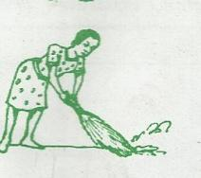6. Match pictures to their actions.**

picking

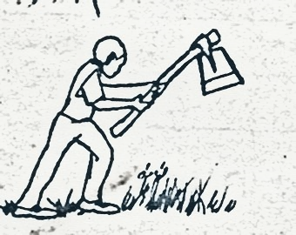

slashing

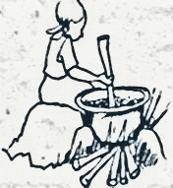

sweeping

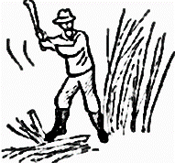

digging

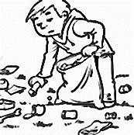

cooking

**7. Name these important people.**

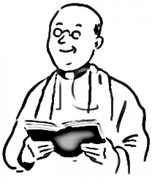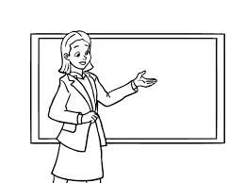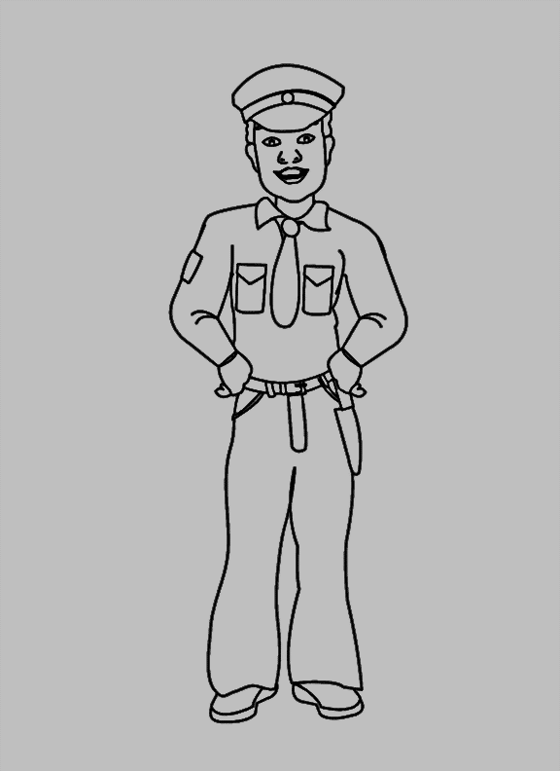

farmer

priest

nurse

teacher

police man

\_\_\_\_\_\_\_\_\_\_\_\_\_\_\_\_\_\_\_\_\_\_\_

\_\_\_\_\_\_\_\_\_\_\_\_\_\_\_\_\_\_\_\_\_\_\_

\_\_\_\_\_\_\_\_\_\_\_\_\_\_\_\_\_\_\_\_\_\_\_

\_\_\_\_\_\_\_\_\_\_\_\_\_\_\_\_\_\_\_\_\_\_\_

\_\_\_\_\_\_\_\_\_\_\_\_\_\_\_\_\_\_\_\_\_\_\_

**8. Name these means of transport.**

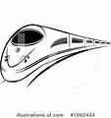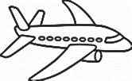

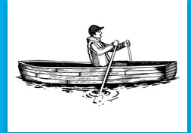



**(car train aero plane boat)**

**9. Draw things found in class.**

book chalk board

pencil chalk

chair table

**10. Cross only things found at home.**

tree broom apple

jug flower skirt

dress pot shoes

ST. MARYS NURSERY SCHOOL - NAKIFUMA

END TERM II EXAMS 2023

LEARNING AREA: HEALTH HABITS

MIDDLE CLASS (4 - 5) YEARS

NAME …………………………………………………..................................................

1. **tick the correct sense for the given body part**

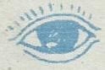seeing mat

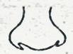

sun smelling

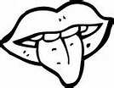

cat tasting

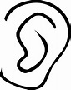

hearing man

moon feeling

**2. Read and draw food we eat.**

|  |  |  |  |  |  |
| --- | --- | --- | --- | --- | --- |
| yam | egg | banana | cassava | rice | fish |
|  |  |  |  |  |  |

**3. Match things used to clean our body.**

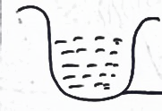

towel

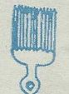

sponge

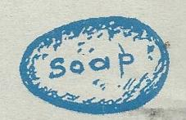

comb

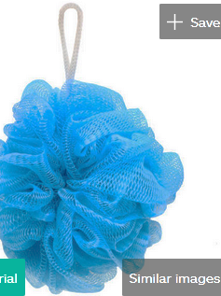

water

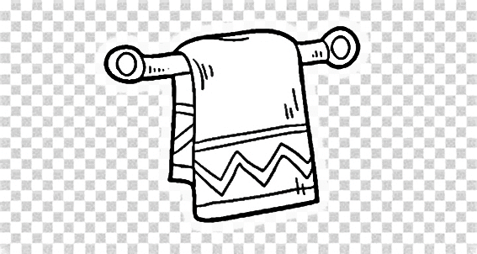

soap

**4. Name these things created by God.**

\_\_\_\_\_\_\_\_\_\_\_\_\_\_\_\_\_\_\_\_\_\_

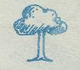

**5. Circle the correct word for the picture.**

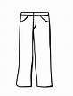

trouser rousert

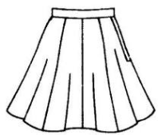

rkiht skirt

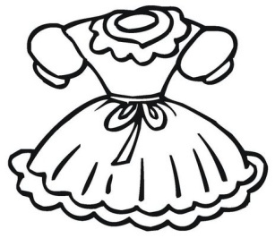

dress ressd



aht hat

1. **Read and draw sources of light.**

moon fire candle

sun star

1. **Name the food we eat**



****



1. **Underline the correct word for the picture.**

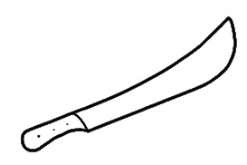

slasher banana

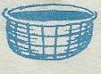

one basket

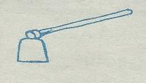

hoe man

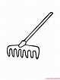

cup rake



pen panga

1. **Circle only dangerous objects.**

mat broken bottle moon

pin star sun

stone spoon wind

cup razorblade man

needle rake yam

1. **fill in the missing letters**

m \_\_\_ ngo

or \_\_\_ nge

\_\_\_ pple

j \_\_\_ ckfruit

p \_\_\_ wpaw

ST. MARYS NURSERY SCHOOL - NAKIFUMA

END TERM II EXAMS 2023

LEARNING AREA 4: NUMBERS

MIDDLE CLASS (4 - 5) YEARS

NAME …………………………………………………..................................................

**1. Write numbers from 1 – 15**

\_\_\_\_\_\_\_\_\_\_\_\_\_\_\_\_\_\_\_\_\_\_\_\_\_\_\_\_\_\_\_\_\_\_\_\_\_\_\_\_\_\_\_\_\_\_\_\_\_\_\_\_\_\_\_\_\_\_\_\_\_

\_\_\_\_\_\_\_\_\_\_\_\_\_\_\_\_\_\_\_\_\_\_\_\_\_\_\_\_\_\_\_\_\_\_\_\_\_\_\_\_\_\_\_\_\_\_\_\_\_\_\_\_\_\_\_\_\_\_\_\_\_

**2. Write the number after.**

9 \_\_\_\_\_\_\_\_

1 \_\_\_\_\_\_\_\_

12 \_\_\_\_\_\_\_\_

6 \_\_\_\_\_\_\_\_

4 \_\_\_\_\_\_\_\_

**3. Add objects to get a number.**



**4. Write in words.**

1 \_\_\_\_\_\_\_\_\_\_\_\_\_\_\_\_\_\_\_\_\_\_

5 \_\_\_\_\_\_\_\_\_\_\_\_\_\_\_\_\_\_\_\_\_\_

7 \_\_\_\_\_\_\_\_\_\_\_\_\_\_\_\_\_\_\_\_\_\_

10 \_\_\_\_\_\_\_\_\_\_\_\_\_\_\_\_\_\_\_\_\_\_

2 \_\_\_\_\_\_\_\_\_\_\_\_\_\_\_\_\_\_\_\_\_\_

**5. Ring the smaller number.**

9 3

4 1

2 8

11 5

6 10

1. **Draw for the number.**

3

9

8

10

5

1. count and write

A set of \_\_\_\_\_\_\_\_\_\_\_\_\_\_\_\_\_\_ chairs.

A set of \_\_\_\_\_\_\_\_\_\_\_\_\_\_\_\_\_\_ dolls



A set of \_\_\_\_\_\_\_\_\_\_\_\_\_\_\_\_\_\_ balls



A set of \_\_\_\_\_\_\_\_\_\_\_\_\_\_\_\_\_\_ pencils



A set of \_\_\_\_\_\_\_\_\_\_\_\_\_\_\_\_\_\_ trees

8. Name the shapes.



ST. MARYS NURSERY SCHOOL - NAKIFUMA

END TERM II EXAMS 2023

LEARNING AREA: SOCIAL DEVELOPMENT

TOP CLASS (5 - 6) YEARS

NAME …………………………………………………..................................................

1. Name these people found at home

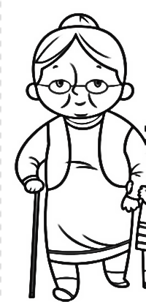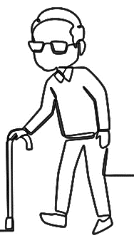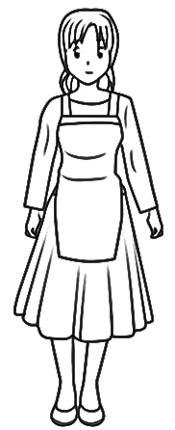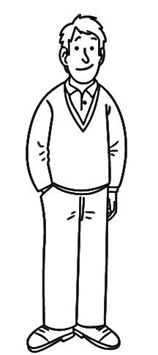

**2. Ring only people found at school.**

sister priest cook

teacher cleaner candle

grow great gate keeper

cup school driver church

**3. Complete the sentences**

\_\_\_\_\_\_\_\_\_\_\_\_\_\_\_\_\_\_\_\_\_\_\_\_\_\_ Keeps law and order

Who teaches children \_\_\_\_\_\_\_\_\_\_\_\_\_\_\_\_\_\_\_\_\_\_\_\_\_\_

\_\_\_\_\_\_\_\_\_\_\_\_\_\_\_\_\_\_\_\_\_\_\_\_\_\_ Cooks food at school

Who heads the school \_\_\_\_\_\_\_\_\_\_\_\_\_\_\_\_\_\_\_\_\_\_\_\_\_\_

\_\_\_\_\_\_\_\_\_\_\_\_\_\_\_\_\_\_\_\_\_\_\_\_\_\_ Collects school fees

**4. Name these important places**

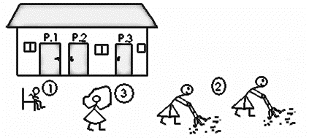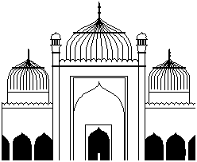

**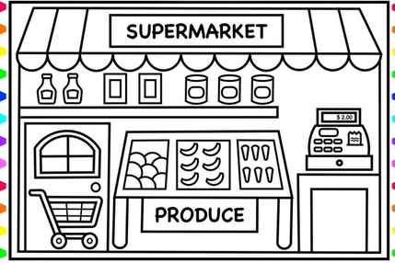**

**5. Fill in the missing letters**

r \_\_\_\_nn \_\_\_\_ \_\_\_\_ g p \_\_\_\_ \_\_\_\_k \_\_\_\_ \_\_\_\_g

sw \_\_\_\_ \_\_\_\_p \_\_\_\_ \_\_\_\_g d\_\_\_\_ gg \_\_\_\_ \_\_\_\_g

mo \_\_\_\_ \_\_\_\_in\_\_\_\_

**6. Name these activities.**

****

****

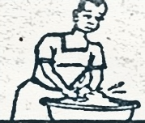

**7. Write the sound for the given animal**

Sheep \_\_\_\_\_\_\_\_\_\_\_\_\_\_\_\_\_\_\_ cat \_\_\_\_\_\_\_\_\_\_\_\_\_\_\_\_\_\_\_

Dog \_\_\_\_\_\_\_\_\_\_\_\_\_\_\_\_\_\_\_ goat \_\_\_\_\_\_\_\_\_\_\_\_\_\_\_\_\_\_\_

**8. Write the animal for the given home**

sty \_\_\_\_\_\_\_\_\_\_\_\_\_\_\_\_\_\_\_\_\_\_\_\_\_\_

kraal \_\_\_\_\_\_\_\_\_\_\_\_\_\_\_\_\_\_\_\_\_\_\_\_\_\_

den \_\_\_\_\_\_\_\_\_\_\_\_\_\_\_\_\_\_\_\_\_\_\_\_\_\_

water \_\_\_\_\_\_\_\_\_\_\_\_\_\_\_\_\_\_\_\_\_\_\_\_\_\_

kennel \_\_\_\_\_\_\_\_\_\_\_\_\_\_\_\_\_\_\_\_\_\_\_\_\_\_

**9. Underline the animal for the given young ones**

kitten cow cup cat

calf kid goat cow

lamb piglet pine sheep

puppy dog den dig

kid sheep goat kitten

**10. Read and draw**

radio news papers

telephone television

drum

ST. MARYS NURSERY SCHOOL - NAKIFUMA

END TERM II EXAMS 2023

LEARNING AREA: NUMBERS

TOP CLASS (5 - 6) YEARS

NAME …………………………………………………..................................................

**1. Fill in the missing numbers.**

12 \_\_\_\_\_ \_\_\_\_\_ \_\_\_\_\_ 16 \_\_\_\_\_ \_\_\_\_\_

**2. Draw for the number**

9

11

8

5

0

**3. Fill in the missing letters**

\_\_\_hirt\_\_\_ \_\_\_ n

el \_\_\_ \_\_\_ en

t\_\_\_ e \_\_\_ v \_\_\_

f \_\_\_ \_\_\_ tee\_\_\_

f \_\_\_ \_\_\_ r

**4. Ring the smaller number.**

8 4 2

7 9 3

0 1 6

5 10 8

11 2 7

**5. Add objects to get numbers.**



**\_\_\_\_\_\_\_\_\_\_\_\_\_\_**

**6. Take away numbers to get numbers**

5 **–** 5 = \_\_\_\_\_\_\_\_\_\_\_\_\_\_\_\_\_\_\_\_\_\_\_\_\_\_\_\_\_\_\_\_\_\_\_\_\_\_\_

10 **–** 6 = \_\_\_\_\_\_\_\_\_\_\_\_\_\_\_\_\_\_\_\_\_\_\_\_\_\_\_\_\_\_\_\_\_\_\_\_\_\_\_

4 **–** 0 = \_\_\_\_\_\_\_\_\_\_\_\_\_\_\_\_\_\_\_\_\_\_\_\_\_\_\_\_\_\_\_\_\_\_\_\_\_\_\_

9 **–** 4 = \_\_\_\_\_\_\_\_\_\_\_\_\_\_\_\_\_\_\_\_\_\_\_\_\_\_\_\_\_\_\_\_\_\_\_\_\_\_\_

7 **–** 6 = \_\_\_\_\_\_\_\_\_\_\_\_\_\_\_\_\_\_\_\_\_\_\_\_\_\_\_\_\_\_\_\_\_\_\_\_\_\_\_

**7. Name these shapes**



**8. Name these sets**



\_\_\_\_\_\_\_\_\_\_\_\_\_\_\_\_\_\_\_\_\_\_\_\_\_\_\_\_\_\_\_\_\_

\_\_\_\_\_\_\_\_\_\_\_\_\_\_\_\_\_\_\_\_\_\_\_\_\_\_\_\_\_\_\_\_\_

\_\_\_\_\_\_\_\_\_\_\_\_\_\_\_\_\_\_\_\_\_\_\_\_\_\_\_\_\_\_\_\_\_

\_\_\_\_\_\_\_\_\_\_\_\_\_\_\_\_\_\_\_\_\_\_\_\_\_\_\_\_\_\_\_\_\_

\_\_\_\_\_\_\_\_\_\_\_\_\_\_\_\_\_\_\_\_\_\_\_\_\_\_\_\_\_\_\_\_\_

**9. Add**

10 + 5 = \_\_\_\_\_\_\_\_\_\_\_\_\_\_\_\_\_\_\_\_\_\_\_\_\_\_\_\_\_

4 + 6 = \_\_\_\_\_\_\_\_\_\_\_\_\_\_\_\_\_\_\_\_\_\_\_\_\_\_\_\_\_

2 + 0 = \_\_\_\_\_\_\_\_\_\_\_\_\_\_\_\_\_\_\_\_\_\_\_\_\_\_\_\_\_

9 + 3 = \_\_\_\_\_\_\_\_\_\_\_\_\_\_\_\_\_\_\_\_\_\_\_\_\_\_\_\_\_

11 + 4 =\_\_\_\_\_\_\_\_\_\_\_\_\_\_\_\_\_\_\_\_\_\_\_\_\_\_\_\_\_

**10. Count and write in words.**

They are \_\_\_\_\_\_\_\_\_\_\_\_\_\_\_\_\_ sticks

They are \_\_\_\_\_\_\_\_\_\_\_\_\_\_\_\_\_ sweets

It is \_\_\_\_\_\_\_\_\_\_\_\_\_\_\_\_\_ egg

These are \_\_\_\_\_\_\_\_\_\_\_\_\_\_\_\_\_ chairs



I can see \_\_\_\_\_\_\_\_\_\_\_\_\_\_\_\_\_ trees

ST. MARYS NURSERY SCHOOL - NAKIFUMA

END TERM II EXAMS 2023

LEARNING AREA: ENGLISH

TOP CLASS (5 - 6) YEARS

NAME …………………………………………………..................................................

**1. Match correctly**

****

sleeping

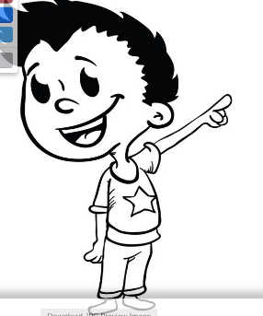

running

****

sitting

****

pointing

C:\Program Files\Microsoft Office\CLIPART\PUB60COR\SL01395_.WMF

dancing

**2. Make sentences from the table.**

|  |  |  |
| --- | --- | --- |
| Jane | has  is  love  am  have | a girl |
| Anna | a nice dress |
| They | four pencils |
| I | six years old |
| I | my teacher |

\_\_\_\_\_\_\_\_\_\_\_\_\_\_\_\_\_\_\_\_\_\_\_\_\_\_\_\_\_\_\_\_\_\_\_\_\_\_\_\_\_\_\_\_\_\_\_\_\_\_\_\_\_\_\_\_\_\_

\_\_\_\_\_\_\_\_\_\_\_\_\_\_\_\_\_\_\_\_\_\_\_\_\_\_\_\_\_\_\_\_\_\_\_\_\_\_\_\_\_\_\_\_\_\_\_\_\_\_\_\_\_\_\_\_\_\_

\_\_\_\_\_\_\_\_\_\_\_\_\_\_\_\_\_\_\_\_\_\_\_\_\_\_\_\_\_\_\_\_\_\_\_\_\_\_\_\_\_\_\_\_\_\_\_\_\_\_\_\_\_\_\_\_\_\_

\_\_\_\_\_\_\_\_\_\_\_\_\_\_\_\_\_\_\_\_\_\_\_\_\_\_\_\_\_\_\_\_\_\_\_\_\_\_\_\_\_\_\_\_\_\_\_\_\_\_\_\_\_\_\_\_\_\_

\_\_\_\_\_\_\_\_\_\_\_\_\_\_\_\_\_\_\_\_\_\_\_\_\_\_\_\_\_\_\_\_\_\_\_\_\_\_\_\_\_\_\_\_\_\_\_\_\_\_\_\_\_\_\_\_\_\_

C:\Program Files\Microsoft Office\CLIPART\PUB60COR\J0151047.WMF**3. Use yes, it is /no, it is not.**

Is this a shirt?

\_\_\_\_\_\_\_\_\_\_\_\_\_\_\_\_\_\_\_\_\_\_\_\_\_\_\_\_\_\_



Is this a bench?

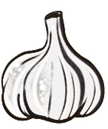\_\_\_\_\_\_\_\_\_\_\_\_\_\_\_\_\_\_\_\_\_\_\_\_\_\_\_\_\_\_

Is this an onion?

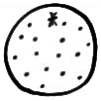\_\_\_\_\_\_\_\_\_\_\_\_\_\_\_\_\_\_\_\_\_\_\_\_\_\_\_\_\_\_

Is this an Apple?

\_\_\_\_\_\_\_\_\_\_\_\_\_\_\_\_\_\_\_\_\_\_\_\_\_\_\_\_\_\_

Is this a pen?

\_\_\_\_\_\_\_\_\_\_\_\_\_\_\_\_\_\_\_\_\_\_\_\_\_\_\_\_\_\_

**4. Fill in the right word.**



This is a \_\_\_\_\_\_\_\_\_\_\_\_\_\_\_\_\_\_\_. I use it to write in my



1 2 3

\_\_\_\_\_\_\_\_\_\_\_\_\_\_\_\_\_\_\_.my \_\_\_\_\_\_\_\_\_\_\_\_\_\_\_\_\_\_\_

1 2 3

writes on a \_\_\_\_\_\_\_\_\_\_\_\_\_\_\_\_\_\_\_using a piece of

\_\_\_\_\_\_\_\_\_\_\_\_\_\_\_\_\_\_\_

**5. Fill in with on, in, under, near, over, behind.**



The tree is\_\_\_\_\_\_\_\_\_\_\_\_\_\_\_\_\_\_\_ the house

****

The man is\_\_\_\_\_\_\_\_\_\_\_\_\_\_\_\_\_\_\_ sitting the chair

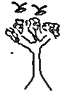

The bird is\_\_\_\_\_\_\_\_\_\_\_\_\_\_\_\_\_\_\_ flying the tree

The bottle is\_\_\_\_\_\_\_\_\_\_\_\_\_\_\_\_\_\_\_ the box



The ball is\_\_\_\_\_\_\_\_\_\_\_\_\_\_\_\_\_\_\_ the chair

1. **Use a / an.**

I can see\_\_\_\_\_\_\_\_\_\_\_\_\_\_\_\_\_\_\_ envelope

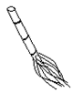

Here is \_\_\_\_\_\_\_\_\_\_\_\_\_\_\_\_\_\_\_ broom



that is\_\_\_\_\_\_\_\_\_\_\_\_\_\_\_\_\_\_\_ insect

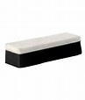

it is\_\_\_\_\_\_\_\_\_\_\_\_\_\_\_\_\_\_\_ duster



this is\_\_\_\_\_\_\_\_\_\_\_\_\_\_\_\_\_\_\_ onion

1. Change one to many.

**one many**

stick \_\_\_\_\_\_\_\_\_\_\_\_\_\_\_\_\_\_\_

duster \_\_\_\_\_\_\_\_\_\_\_\_\_\_\_\_\_\_\_

stool \_\_\_\_\_\_\_\_\_\_\_\_\_\_\_\_\_\_\_

spoon \_\_\_\_\_\_\_\_\_\_\_\_\_\_\_\_\_\_\_

dog \_\_\_\_\_\_\_\_\_\_\_\_\_\_\_\_\_\_\_

**8. Fill in the missing letters.**

r\_\_\_\_ \_\_\_\_ding p\_\_\_\_ \_\_\_\_nting d\_\_\_\_ nc\_\_\_\_ ng

s\_\_\_\_ t\_\_\_\_ ng wr\_\_\_\_ t\_\_\_\_ ng

**9. What is this?**



**\_\_\_\_\_\_\_\_\_\_\_\_\_\_\_\_\_\_\_\_\_\_\_\_**

**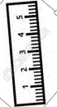**

**\_\_\_\_\_\_\_\_\_\_\_\_\_\_\_\_\_\_\_\_\_\_\_\_**



**\_\_\_\_\_\_\_\_\_\_\_\_\_\_\_\_\_\_\_\_\_\_\_\_**



**\_\_\_\_\_\_\_\_\_\_\_\_\_\_\_\_\_\_\_\_\_\_\_\_**



**\_\_\_\_\_\_\_\_\_\_\_\_\_\_\_\_\_\_\_\_\_\_\_\_**

**10. Count and fill correctly.**

It is **\_\_\_\_\_\_\_\_\_\_\_\_\_\_\_\_\_\_**tree

Here are **\_\_\_\_\_\_\_\_\_\_\_\_\_\_\_\_\_\_**sticks

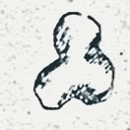

These are **\_\_\_\_\_\_\_\_\_\_\_\_\_\_\_\_\_\_**stones

Those are **\_\_\_\_\_\_\_\_\_\_\_\_\_\_\_\_\_\_**eggs

I can see **\_\_\_\_\_\_\_\_\_\_\_\_\_\_\_\_\_\_**chairs

ST. MARYS NURSERY SCHOOL - NAKIFUMA

END TERM II EXAMS 2023

LEARNING AREA: TAKING CARE

TOP CLASS (5 - 6) YEARS

NAME …………………………………………………..................................................

**1. Fill in the missing letters.**

f \_\_\_\_sh b \_\_\_\_ \_\_\_\_ d sn\_\_\_\_k \_\_\_\_

fl \_\_\_\_we \_\_\_\_ m \_\_\_\_ \_\_\_\_n

**2. Make sentences**

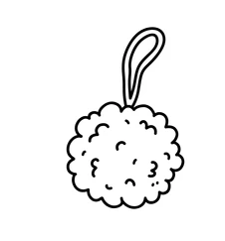

**\_\_\_\_\_\_\_\_\_\_\_\_\_\_\_\_\_\_\_\_\_\_\_\_\_\_\_\_\_\_\_\_\_\_\_\_\_\_\_\_\_**



**\_\_\_\_\_\_\_\_\_\_\_\_\_\_\_\_\_\_\_\_\_\_\_\_\_\_\_\_\_\_\_\_\_\_\_\_\_\_\_\_\_**

**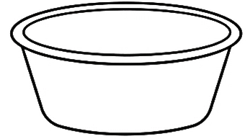**

**\_\_\_\_\_\_\_\_\_\_\_\_\_\_\_\_\_\_\_\_\_\_\_\_\_\_\_\_\_\_\_\_\_\_\_\_\_\_\_\_\_**

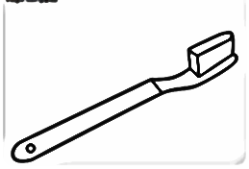

**\_\_\_\_\_\_\_\_\_\_\_\_\_\_\_\_\_\_\_\_\_\_\_\_\_\_\_\_\_\_\_\_\_\_\_\_\_\_\_\_\_**

**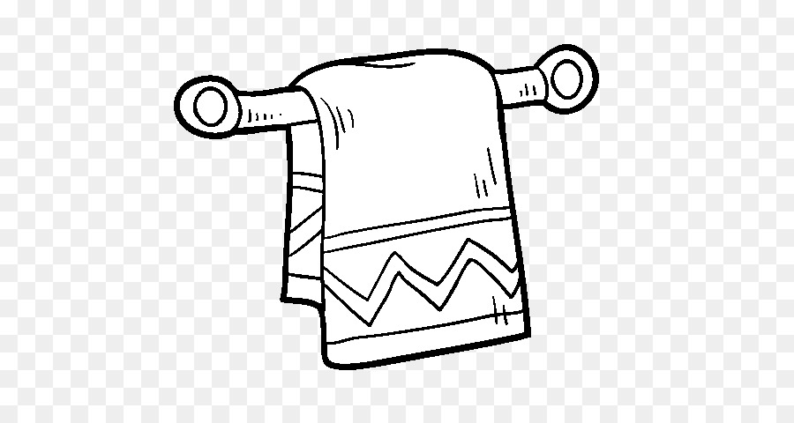**

**\_\_\_\_\_\_\_\_\_\_\_\_\_\_\_\_\_\_\_\_\_\_\_\_\_\_\_\_\_\_\_\_\_\_\_\_\_\_\_\_\_**

**3. Underline only fruits.**

meat mango man

apple flower stone

sleeping reading pineapple

orange over owl

tin tomato tree

**4. Name these accidents.**

**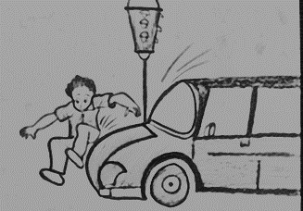**

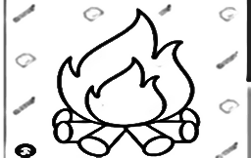

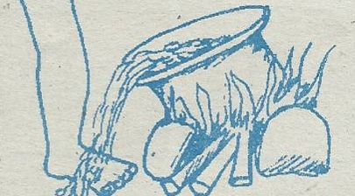

P

P

**5. Complete these sentences.**

We use a nose for \_\_\_\_\_\_\_\_\_\_\_\_\_\_\_\_\_\_\_\_\_\_\_

We use eyes for \_\_\_\_\_\_\_\_\_\_\_\_\_\_\_\_\_\_\_\_\_\_\_

We use a skin for \_\_\_\_\_\_\_\_\_\_\_\_\_\_\_\_\_\_\_\_\_\_\_

We use a tongue for \_\_\_\_\_\_\_\_\_\_\_\_\_\_\_\_\_\_\_\_\_\_\_

We use legs for \_\_\_\_\_\_\_\_\_\_\_\_\_\_\_\_\_\_\_\_\_\_\_

**6. Name these sources of water.**



\_\_\_\_\_\_\_\_\_\_\_\_\_\_\_\_\_\_\_\_\_\_\_\_



\_\_\_\_\_\_\_\_\_\_\_\_\_\_\_\_\_\_\_\_\_\_\_\_

\_\_\_\_\_\_\_\_\_\_\_\_\_\_\_\_\_\_\_\_\_\_\_\_

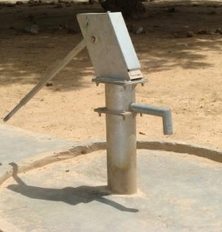

\_\_\_\_\_\_\_\_\_\_\_\_\_\_\_\_\_\_\_\_\_\_\_\_

\_\_\_\_\_\_\_\_\_\_\_\_\_\_\_\_\_\_\_\_\_\_\_\_

**7. Read and draw.**

shoes hat belt

dress trouser

1. **write correctly**

abanna \_\_\_\_\_\_\_\_\_\_\_\_\_\_\_\_\_\_\_\_\_\_\_\_

gge \_\_\_\_\_\_\_\_\_\_\_\_\_\_\_\_\_\_\_\_\_\_\_\_

neasb \_\_\_\_\_\_\_\_\_\_\_\_\_\_\_\_\_\_\_\_\_\_\_\_

sihf \_\_\_\_\_\_\_\_\_\_\_\_\_\_\_\_\_\_\_\_\_\_\_\_

ssavaca \_\_\_\_\_\_\_\_\_\_\_\_\_\_\_\_\_\_\_\_\_\_\_\_

1. **Name these dangerous objects.**

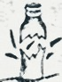

\_\_\_\_\_\_\_\_\_\_\_\_\_\_\_\_\_\_\_\_\_\_\_\_

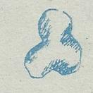

\_\_\_\_\_\_\_\_\_\_\_\_\_\_\_\_\_\_\_\_\_\_\_\_

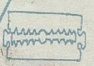

\_\_\_\_\_\_\_\_\_\_\_\_\_\_\_\_\_\_\_\_\_\_\_\_

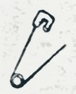

\_\_\_\_\_\_\_\_\_\_\_\_\_\_\_\_\_\_\_\_\_\_\_\_

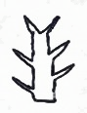

\_\_\_\_\_\_\_\_\_\_\_\_\_\_\_\_\_\_\_\_\_\_\_\_

1. **Mention five things created by God.**

\_\_\_\_\_\_\_\_\_\_\_\_\_\_\_\_\_\_\_\_\_\_\_\_

\_\_\_\_\_\_\_\_\_\_\_\_\_\_\_\_\_\_\_\_\_\_\_\_

\_\_\_\_\_\_\_\_\_\_\_\_\_\_\_\_\_\_\_\_\_\_\_\_

\_\_\_\_\_\_\_\_\_\_\_\_\_\_\_\_\_\_\_\_\_\_\_\_

\_\_\_\_\_\_\_\_\_\_\_\_\_\_\_\_\_\_\_\_\_\_\_\_

ST. MARYS NURSERY SCHOOL - NAKIFUMA

END TERM II EXAMS 2023

LEARNING AREA: READING

TOP CLASS (5 - 6) YEARS

NAME …………………………………………………..................................................

1. Join and form words.

s

g

t

i

sp

t

d

l

k

n

oo

\_\_\_\_\_\_\_\_\_\_\_\_\_\_\_\_\_\_\_\_\_\_\_\_

\_\_\_\_\_\_\_\_\_\_\_\_\_\_\_\_\_\_\_\_\_\_\_\_

\_\_\_\_\_\_\_\_\_\_\_\_\_\_\_\_\_\_\_\_\_\_\_\_

\_\_\_\_\_\_\_\_\_\_\_\_\_\_\_\_\_\_\_\_\_\_\_\_

\_\_\_\_\_\_\_\_\_\_\_\_\_\_\_\_\_\_\_\_\_\_\_

1. Search for words of sound a from the puzzle.

|  |  |  |  |
| --- | --- | --- | --- |
| m | a | t | b |
| a | n | a | a |
| n | t | p | g |

\_\_\_\_\_\_\_\_\_\_\_\_\_\_\_\_\_\_\_\_\_\_\_\_

\_\_\_\_\_\_\_\_\_\_\_\_\_\_\_\_\_\_\_\_\_\_\_\_

\_\_\_\_\_\_\_\_\_\_\_\_\_\_\_\_\_\_\_\_\_\_\_\_

\_\_\_\_\_\_\_\_\_\_\_\_\_\_\_\_\_\_\_\_\_\_\_\_

\_\_\_\_\_\_\_\_\_\_\_\_\_\_\_\_\_\_\_\_\_\_\_\_

1. **Match and write the correct word.**

fl urch \_\_\_\_\_\_\_\_\_\_\_\_\_\_\_\_

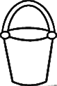

gl eet \_\_\_\_\_\_\_\_\_\_\_\_\_\_\_\_

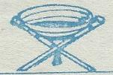

st ower \_\_\_\_\_\_\_\_\_\_\_\_\_\_\_\_

ch ass \_\_\_\_\_\_\_\_\_\_\_\_\_\_\_\_

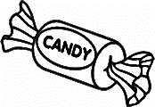

sw ool \_\_\_\_\_\_\_\_\_\_\_\_\_\_\_\_

1. **Form syllables.**

oa

t

b

r

c

\_\_\_\_\_\_\_\_\_\_\_\_\_\_\_\_\_\_\_\_\_\_\_

\_\_\_\_\_\_\_\_\_\_\_\_\_\_\_\_\_\_\_\_\_\_\_

\_\_\_\_\_\_\_\_\_\_\_\_\_\_\_\_\_\_\_\_\_\_\_

\_\_\_\_\_\_\_\_\_\_\_\_\_\_\_\_\_\_\_\_\_\_\_

1. **underline words with sound ai**

Our maid is good

She has long nails

Our cook is in jail

No gain without pain

My mother will Cain you

**6. Tell these sounds.**

cr mb sp sn sh ph

**7. Read these sentences.**

The pencil is short

Did you eat the mango

All bags are lost

Their father has come

These are leaves

I can see a tree

**8. Listen and write.**

\_\_\_\_\_\_\_\_\_\_\_\_\_\_\_\_\_\_\_\_\_\_\_\_

\_\_\_\_\_\_\_\_\_\_\_\_\_\_\_\_\_\_\_\_\_\_\_\_

\_\_\_\_\_\_\_\_\_\_\_\_\_\_\_\_\_\_\_\_\_\_\_\_

\_\_\_\_\_\_\_\_\_\_\_\_\_\_\_\_\_\_\_\_\_\_\_\_

\_\_\_\_\_\_\_\_\_\_\_\_\_\_\_\_\_\_\_\_\_\_\_\_

**9. Find the picture number.**

|  |  |  |  |
| --- | --- | --- | --- |
| 5926BA10 |  |  |  |
| Cooking | Playing | Cutting the tree | Carrying fire wood |

1. The children are playing in picture number

\_\_\_\_\_\_\_\_\_\_\_\_\_\_\_\_\_\_\_\_\_\_\_\_\_\_\_\_\_\_\_\_\_\_\_\_\_\_\_\_\_\_\_\_\_\_\_\_\_\_\_\_\_\_\_\_\_

1. Mother is cooking in picture number

\_\_\_\_\_\_\_\_\_\_\_\_\_\_\_\_\_\_\_\_\_\_\_\_\_\_\_\_\_\_\_\_\_\_\_\_\_\_\_\_\_\_\_\_\_\_\_\_\_\_\_\_\_\_\_\_\_

1. What can you see in picture number 3

\_\_\_\_\_\_\_\_\_\_\_\_\_\_\_\_\_\_\_\_\_\_\_\_\_\_\_\_\_\_\_\_\_\_\_\_\_\_\_\_\_\_\_\_\_\_\_\_\_\_\_\_\_\_\_\_\_

1. Who is carrying fire wood in picture number 4

\_\_\_\_\_\_\_\_\_\_\_\_\_\_\_\_\_\_\_\_\_\_\_\_\_\_\_\_\_\_\_\_\_\_\_\_\_\_\_\_\_\_\_\_\_\_\_\_\_\_\_\_\_\_\_\_\_

**10. Read the story and answer questions**

Mum is preparing tea for Dave. There is a cake to bake, a jelly to make a lots more but she will get everything thing ready in time.

**Questions.**

1. Who is preparing tea for Dave?

\_\_\_\_\_\_\_\_\_\_\_\_\_\_\_\_\_\_\_\_\_\_\_\_\_\_\_\_\_\_\_\_\_\_\_\_\_\_\_\_\_\_\_\_\_\_\_\_\_\_\_\_\_\_\_\_\_

1. What will mum bake

\_\_\_\_\_\_\_\_\_\_\_\_\_\_\_\_\_\_\_\_\_\_\_\_\_\_\_\_\_\_\_\_\_\_\_\_\_\_\_\_\_\_\_\_\_\_\_\_\_\_\_\_\_\_\_\_\_

1. Write down three words with sound a-r from the story.

\_\_\_\_\_\_\_\_\_\_\_\_\_\_\_\_\_\_\_\_\_\_\_\_\_\_\_\_\_\_\_\_\_\_\_\_\_\_\_\_\_\_\_\_\_\_\_\_\_\_\_\_\_\_\_\_\_